**Power BI Assignment 3**

1. List and explain different PowerBi products?

The different products offered by Microsoft are:

1. Power BI Desktop :

Microsoft Power BI Desktop is built for the analyst. It combines state-of-the-art interactive visualizations, with industry-leading data query and modeling built-in. Create and publish your reports to Power BI. Power BI Desktop helps you empower others with timely critical insights, anytime, anywhere.

1. Power BI Pro :

Power BI Pro is an individual user license that allows access to all content and capabilities in the Power BI service. You can even share content and collaborate with other Pro users. Only Pro users can publish content to other workspaces, share dashboards, and subscribe to dashboards and reports.

1. Power BI Premium

Power BI Premium is a capacity-based offering that includes: Flexibility to publish reports broadly across an enterprise, without requiring recipients to be licensed individually per user. Greater scale and performance than shared capacity in the Power BI service.

1. Power BI Mobile

The Android app for Microsoft Power BI delivers the mobile BI experience for Power BI, Power BI Report Server, and Reporting Services. View and interact with your company dashboards on premises and in the cloud from anywhere, with live, touch-enabled mobile access. Explore the data in dashboards, and share with your colleagues in email or text messages.

1. Power BI Embedded

Power BI embedded analytics allows you to embed your Power BI items such as reports, dashboards and tiles, in a web application or in a website. You can: Deliver compelling data experiences for your end users, enabling them to take action based on insights from your solutions data.

1. Power BI Report Server

Image result for power bi report service

A Power BI report is a multi-perspective view into a data model, with visualizations that represent different findings and insights from that data model. A report can have a single visualization or pages full of visualizations. Depending on your role, you may read and explore reports, or you may create them for others

1. What limitations of Excel, Microsoft solved by PowerBi?

Microsoft Excel is mainly used for simple analysis tasks on historical data only while Power BI deals with the simplification of real-time data obtained from disparate sources, apart from complex analysis of historical data.

### Power BI vs Excel: Language Dependency

Microsoft Excel works with the MDX language for querying the underlying Data Model, while for Power BI, the DAX language is used

### Power BI vs Excel: Collaboration

Power BI lets you share your dashboards and reports with other employees in just a few clicks. This is available for people looking for On-Premise Solutions or In-Cloud Solutions catering to enterprises and small businesses alike.

Microsoft Excel, however, has limited scope for collaboration, integration, and a bunch of other functions and formats. Setting KPIs and organizing complex data structures is simpler in Microsoft Excel due to the presence of a rich set of mathematical formulas to help you along the way.

### Power BI vs Excel: Data Security

Microsoft Excel allows you to restrict access to a file, worksheet, or workbook. You can also lock the files to hide their visibility or give read-only access to prevent editing or modifications. This is all Microsoft Excel has to offer when it comes to Data Security. It does not have a robust, built-in security control, unlike Power BI. Power BI offers a rich assortment of measures to keep your customer data safe like:

* Row-Level Security Feature
* Role-Based Authentication
* Networking Security
* Risk Mitigation
* Session Monitoring
* Cloud-Based Security Provisions

### Power BI vs Excel: Data Visualizations

When it comes to data visualizations, Power BI trumps Microsoft Excel by its sheer ability to analyze a vast amount of data with great ease along with a wide range of charts like Tables, Area Charts, Doughnut Charts, Funnel Charts, etc.

### Power BI vs Excel: Reporting and Dashboarding

Microsoft Excel offers you a limited range of dashboards if you look at interactivity and the range of functions. It has a tabular data format that can help you visualize data with various chart formats. However, it is not an ideal tool for larger datasets. Power BI has a cohort of powerful features like easy formatting, natural language querying, resizing, editing, and filtering that make the reports easy to understand, and visually attractive, while helping you draw multi-faceted insights to guide the decision-making process. Power BI’s reports are highly dynamic and interactive.

1. Explain PowerQuery?

Power Query is a data transformation and data preparation engine. Power Query comes with a graphical interface for getting data from sources and a Power Query Editor for applying transformations. Because the engine is available in many products and services, the destination where the data will be stored depends on where Power Query was used. Using Power Query, you can perform the extract, transform, and load (ETL) processing of data

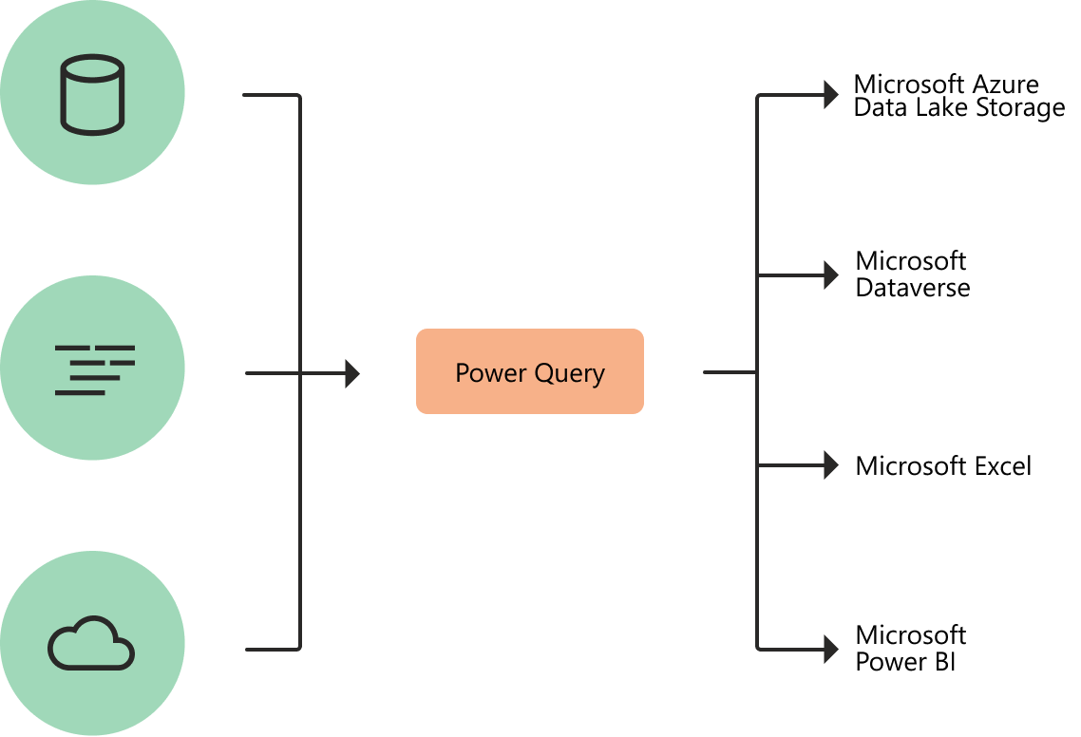

1. Explain PowerMap?

A power map lets you discover insights you might not see in traditional two-dimensional (2-D) tables and charts. With Power Map, you can plot geographic and temporal data on a 3-D globe or custom map, show it over time, and create visual tours you can share with other people.

1. How powerBi eliminated the need to host SharePoint Server on premises?

* PowerBI is a cloud technology for reporting as however it has also an on-premises solution for which we have PowerBI Report Server.
* PowerBI Reporting server is an instance of reporting services . Its an whole server hosting environment you setup on premises and you can have Powerbi reports in it . so basically it’s a centralized hosting environment which can have your interactive powerbi reports which eliminate the need to host sharepoint server on premises.

1. Explain the updates done in Power Bi Service(power BI 2.0) as compared to older version ?

The biggest difference between these two systems is the way in which they are deployed. Power BI is a cloud-based software and is hosted on the vendor's servers and accessed through a web browser, whereas, MSBI is an on-premise software is installed locally, on a company's own computers and servers.29